New Features

This document lists features that have been added to the Contract and Reservation modules since the last GIS update. The changes only affect the Payment tab in the Contract modules, the Customer & Payment tab in the Reservation module as well as the Deposit/Refund Record screen. Credit card numbers will now be masked in all Reservation and Contract modules as well as the Location EOD Reconciliation Report.

Introduction

A chip card is a credit or debit card with a microchip embedded in it. This chip is encrypted and provides enhanced security and protection to help guard against fraud. When you use a chip at stores or restaurants with chip-enabled terminals, the system will validate the chip, and you have to enter a personal identification number (PIN) to ensure a more secure transaction.

With the emerging popularity and global implementation of chip technology, Canadian banks and credit card companies have also committed to migrating to chip. All merchants are required to upgrade/replace their point-of-sale systems and convert their payment systems to chip technology prior to 31st March 2011.

Budget Rent-a-Car of B.C. Ltd. has successfully upgraded GIS to accept chip cards. New PINpads will be installed at each CSR’s terminal to process credit and debit card transactions. A stand alone POS machine will still be available at each location in the case of an Internet connection failure.

Swiping a chip card is essentially the same as swiping a regular credit card with no chip and offers no extra protection. Therefore, to reduce fraud and credit card disputes, you MUST ALWAYS insert a chip card into the PINpad instead of swiping it.

To ensure that GIS is PCI*-compliant and to further protect cardholder data, all stored credit card numbers will only display the first and last four digits.

* PCI stands for Payment Card Industry.
Contract Open/ Check Out

As of the new implementation, you must make sure that ALL coverages (E.g.: LDW), optional extras and sales accessories are selected before proceeding to the Payment tab to authorize or collect deposit (See Figure 1). This step must be done before pre-writing or opening a contract.

Always use a PINpad to process deposits, authorizations, payments and refunds.

IMPORTANT
You MUST NOT swipe/insert the credit card just to test its validity!

Any transaction made via the PINpad will be sent to the bank immediately.
Switching to the Payment tab is the last step before assigning a unit to the contract.
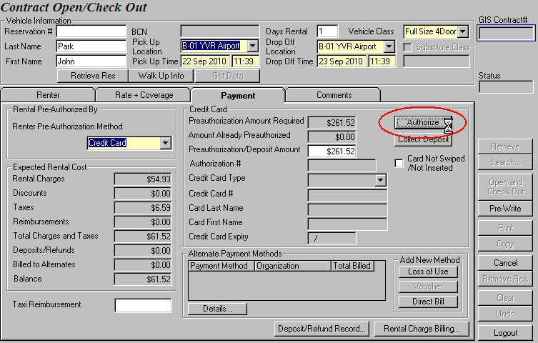
Figure 1: Only authorize or collect deposit once you are sure of the total rental cost.

How to Authorize/ Collect Deposit?

- Enter the amount you need to collect or preauthorize in the Preauthorization/Deposit Amount field.
(The default amount = expected rental charges + $200)

- Click Authorize or Collect Deposit.
IMPORTANT
If the rental is over 14 days, you must collect the full rental amount, and authorize an additional $200 on the customer’s credit card.

Therefore, make sure that you have added all the necessary coverage, optional extras and sales accessories before you process the credit card so that you will not charge the customer anything less than required.

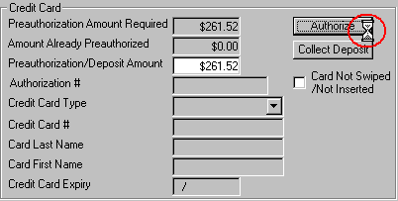
- Once you see the hourglass, go to your PINpad and see that it displays the “INSERT OR SWIPE CARD” message (See Figure 2).
Notice that the hourglass icon appears after you click Authorize or Collect Deposit.
What is the Card Not Swiped /Not Inserted box for?
You may on click on the Card Not Swiped / Not Inserted box to manually enter credit card information only if the customer presents the following credit card types:
- BML Leasing - International Brac - PH&H
- GE Capital- One Trip Voucher

- If the customer presents a chip-enabled credit card
→ INSERT card into the PINpad
If the customer presents a normal credit card with no chip
→ SWIPE card on the PINpad
Figure 2: The hourglass is an indicator that the PINpad is prompting you for an action.

- Once the PINpad approves of the transaction, you will see that all credit card information are downloaded in GIS, as shown in Figure 3.

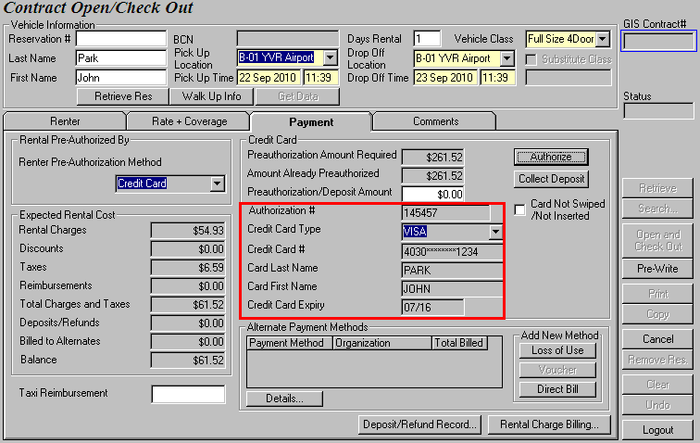
GIS obtains the credit card information.
The authorization transaction is sent to the bank.
Figure 3: Using the PINpad eliminates the process of manually entering credit card information.

- Click Open and Check Out.

IMPORTANT
If you do two separate transactions in the Payment tab, say, you collect deposit and then authorize, make sure that you process both transactions on the same credit card. The first credit card you use to process any transaction in Contract Open will be known as the primary/original credit card to GIS.

What is the “Card Not Swiped/Not Inserted” box for?
You may click on the Card Not Swiped/Not Inserted box to manually enter credit card information only if the customer presents the following credit card types:
- BML Leasing - International BRAC - PH&H
- GE Capital - One Trip Voucher

When these cards are used, clicking Authorize, Collect Deposit, Collect Payment, Issue Refund buttons will bring up the Manual Credit Card Authorization screen (See Figure 4). Any transactions processed through this screen will not go to the bank.

As a rule of thumb, whenever the Card Not Swiped/Not Inserted box is selected, you will not be using the PINpad when you click on the Authorize, Collect Deposit, Collect Payment and Issue Refund buttons.

If it is not selected, the PINpad will always prompt you to insert or swipe card when you select Authorize, Collect Deposit, Collect Payment and Issue Refund.

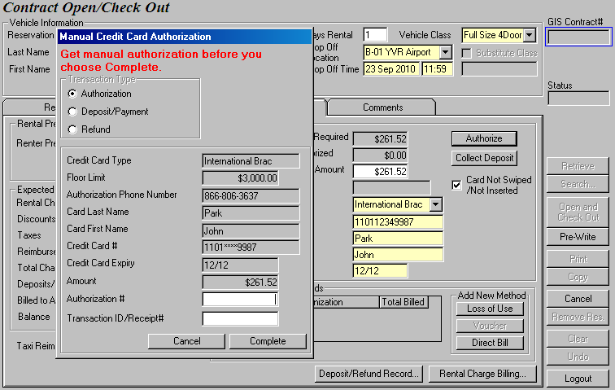
Figure 4: Process authorizations, payments/refunds manually through Manual Credit Card Authorization.
FastBreak Rental

When you retrieve a FastBreak reservation, the FastBreak customer’s default settings and preferences will be retrieved and grayed out. With all the fields grayed out, you will not be able to modify any of the default settings.

GIS now gives you a straightforward solution to change FastBreak customers’ default settings. If you realize that the FastBreak customer’s default credit card has expired, you may want to notify the customer and ask for a valid credit card. Next, click on the Update CC Info button to change the customer’s credit card details (See Figure 5).

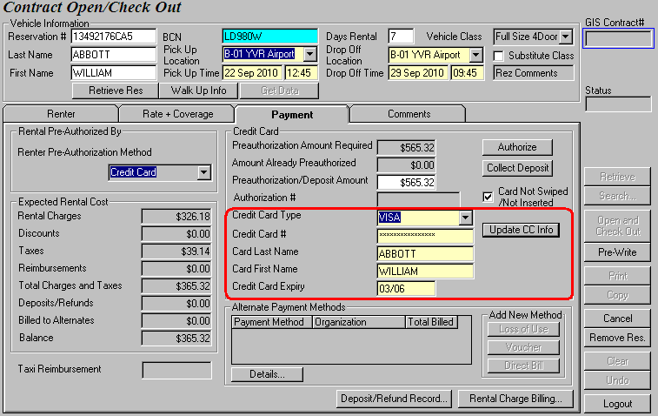
Clicking on the Update CC Info button will enable the credit card fields.
Figure 5: Instead of deleting the BCN field, select Update CC Info to change the default credit card settings.
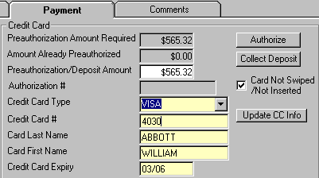
Once the credit card fields are enabled, you can either change the credit card information manually or swipe/insert a new credit card. Notice that the credit card number is displayed as you enter it (See Figure 6), but once the transaction is processed or when the credit card number is saved on GIS, it will be masked. To use the pinpad, clear all credit card fields, deselect the Card Not Swiped/Not Inserted option and click Authorize or Collect Deposit.
Figure 6: Credit card number is not masked upon data entry.

IMPORTANT
Remember to take an imprint of the new credit card and obtain the customer’s signature on the open contract to acknowledge the change in credit card information.

Contract Changes

There are no major changes in the Contract Changes module except for the Deposit/Refund Record screen. You will see that Deposit/Refund Record has now incorporated the Card Not Swiped/Not Inserted box. GIS also stores the information of the customer’s primary credit card in the Credit Card Authorizations section here, as shown in Figure 7.

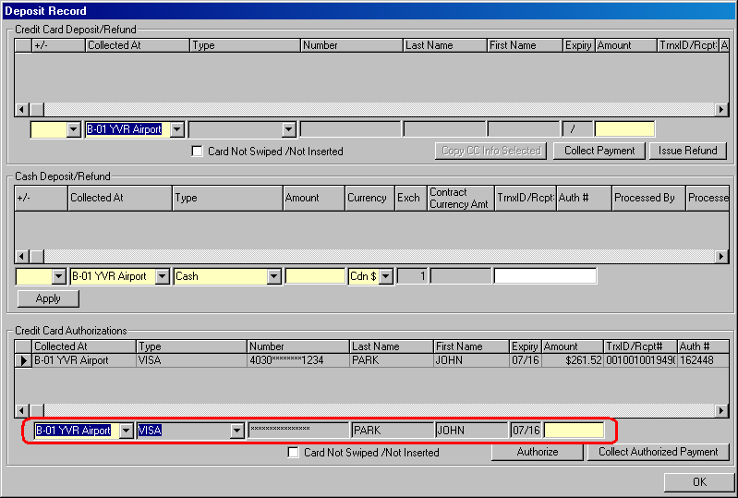
Notice that the primary credit card information is saved and cannot be changed.
Figure 7: You can find the primary credit card information in the Credit Card Authorizations section.

If there is a record in the Credit Card Deposit/Refund section in the Deposit/Refund Record screen, notice that the Copy CC Info Selected button is enabled. To collect another payment or to do a refund, you must first select the record which contains the credit card you want to process on, as shown in Figure 8. Selecting the first record is essentially the same as selecting the VISA card. Selecting the second record however means you are choosing the AMEX card.

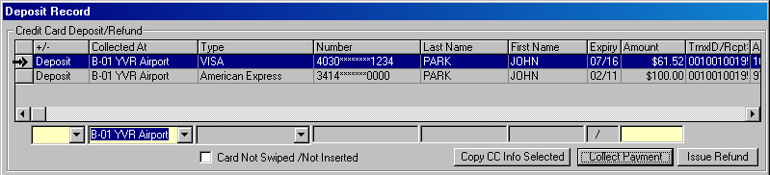
Figure 8: Select the record from the grid before you click the Copy CC Info Selected button.

After the record is selected, click on the Copy CC Info Selected button to copy down the credit card information into the empty fields (See Figure 9). Then you can proceed to select the transaction type and enter the transaction amount. Recall that if your work station is not connected to a PINpad, you must select the Card Not Swiped/Not Inserted box before carrying out the payment or refund transaction.

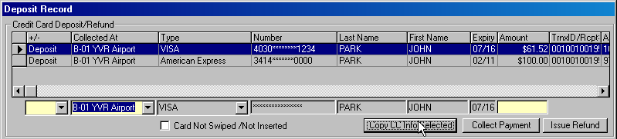
Figure 9: The Copy CC Info Selected button copies the selected credit card data into the fields below.
Contract Check In

Fill in all the required fields in the Check In Vehicle tab before you switch to the Payment tab. In the most common situation where customers put the whole rental on the authorizing credit card, click on the Collect Payment button and you are ready to check in the vehicle after the payment is automatically charged to the credit card (See Figure 10).

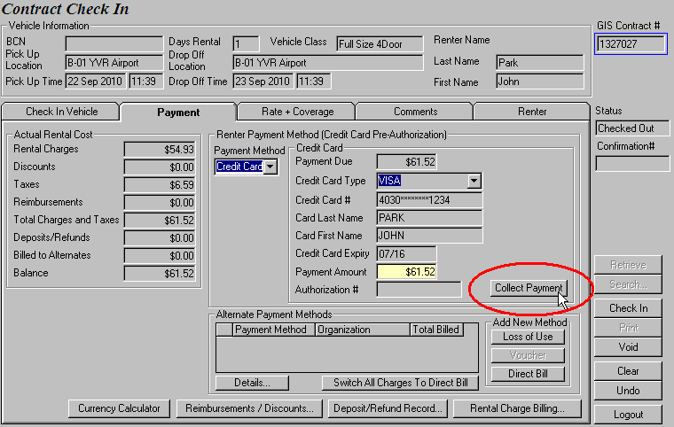
Charge the rental balance to the authorizing credit card by clicking Collect Payment.
Figure 10: If the customer wishes to pay with the authorizing credit card, just click Collect Payment.

Upon returning the vehicle, the customer may choose to use his/her debit card to pay for any outstanding rental charges instead of charging them to the authorizing credit card. In that case, change the Payment Method in the Renter Payment Method section of the Payment tab to ‘Cash’.

How to Collect Payment Using a Debit Card?

- In the Payment tab, select ‘Cash’ as the payment method, change the Payment Method field in the Cash section to ‘Debit Card’.

- Enter the Payment Amount that the customer wishes to pay with his/her debit card.
(GIS defaults the Payment Amount to the total rental cost.)

- Click on the Collect Payment button.

- Once you see the hourglass (See Figure 11), go to your PINpad and see that it displays the “INSERT OR SWIPE CARD” message.
- If the customer presents a chip-enabled debit card
→ INSERT card into the PINpad
If the customer presents a normal debit card with no chip
→ SWIPE card on the PINpad

- Hand the PINpad to the customer. Let the customer confirm the payment by choosing from a Chequing or Savings account and entering a PIN.

- Three scenarios might occur at this point – the PINpad may approve the transaction, decline it, or not complete it. Let’s focus on the approved transaction for now.

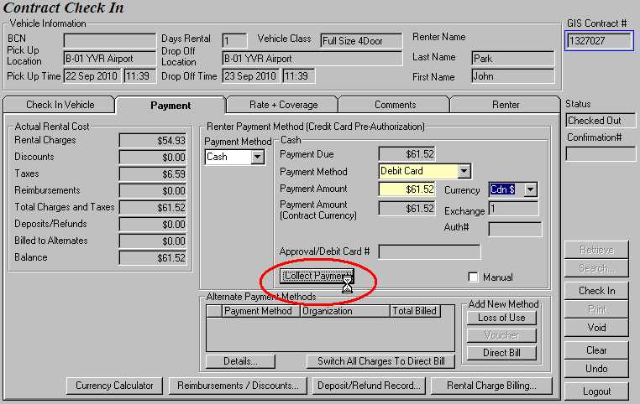
The hourglass appears upon clicking Collect Payment.

Figure 11: The hourglass appears again – you know that your PINpad is ready to process the payment.

- Once the PINpad approves of the transaction, the Debit Card # and Authorization # fields are populated in GIS.

- Check in the vehicle.

PINpad rejects transactions?
There are many scenarios where the PINpad rejects a debit card transaction, all you need to do is click on the Collect Payment button and swipe the debit card again.

Examples of failed debit transactions:
1) The customer accidentally presses the Cancel button on the PINpad
(See Figure 12)
2) The customer enters an incorrect PIN (See Figure 13)
3) The customer selects the wrong Chequing/Savings account

IMPORTANT
Whenever the PINpad rejects a debit transaction, GIS displays a warning message about the debit card not being authorized and two copies of a decline receipt will be printed. Give the customer a copy of the receipt and the check in contract. Staple the remaining receipt to Budget’s copy of the check in contract.

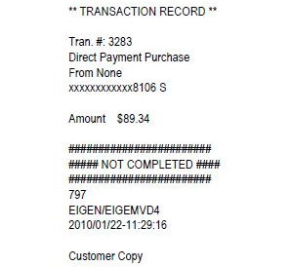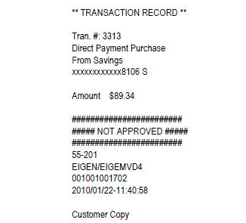
Figure 12: Receipt for clicking Cancel on PINpad. Figure 13: Receipt for entering the wrong PIN.

Changing Credit Cards

As previously mentioned, if the customer wants to pay for the rental cost with the original credit card, you can process the payment by selecting Collect Payment and the payment is automatically charged to the credit card.

- However, if the customer wants to use a new credit card to pay for the rental or a portion of the rental amount, proceed to the Deposit/Refund Record screen to charge the amount to the new credit card.

IMPORTANT
Remember to take an imprint of the new credit card and obtain the customer’s signature in the printed check in contract to acknowledge the change in payment method.

- If the customer has declined LDW coverage because their credit card covers it, the credit card information are saved on the Deposit/Refund Record screen (See Figure 14) and all rental charges should be processed on that credit card.

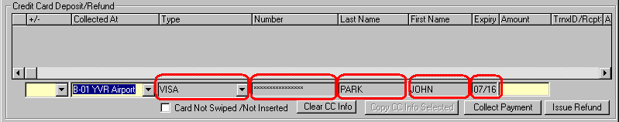
The credit card used to cover LDW is saved here.
Figure 14: The credit card’s LDW coverage is only valid if all rental payments are applied to the card.

However, if the customer prefers to use a new credit card to make a payment, explain to the customer what the liability will be. If the customer insists on using the new credit card, go to the Deposit/Refund Record screen and click on the Clear CC Info button. A warning message, as shown in Figure 15, is displayed upon clicking the button.

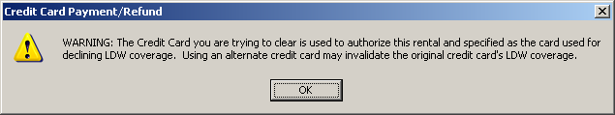
Figure 15: Removing the credit card that offers LDW coverage will trigger this warning message.

With all the credit card fields cleared, you can now fill in the +/- and Amount fields and click Collect Payment. Go to the PINpad to swipe or insert a credit card. The payment should go through successfully.

IMPORTANT
Remember to take an imprint of the new credit card and obtain the customer’s signature in the printed check in contract to acknowledge the change in payment method.

Contract Adjustments

Like the Contract Changes module, the only change in Contract Adjustments is the addition of the Card Not Swiped/Not Inserted box and the Copy CC Info Selected button on the Deposit/Refund Record screen.

- If the customer is present at the location when the adjustment is made, make sure that you obtain his/her credit card or the debit card and process it on the PINpad.

- If the customer is on the phone when the adjustment is made, select the Card Not Swiped/Not Inserted box on the Deposit/Refund Record screen, copy the customer’s credit card information and enter the adjustment amount.

Reservation

Fill in all required fields before you collect the deposit from the customer. However, if a customer calls in, there is no way for you to insert/swipe the customer’s credit card on the PINpad and charge the deposit to it. GIS has anticipated this scenario and has left the credit card fields available by default for data entry (See Figure 16). Key in the customer’s credit card information manually and click Collect Deposit.

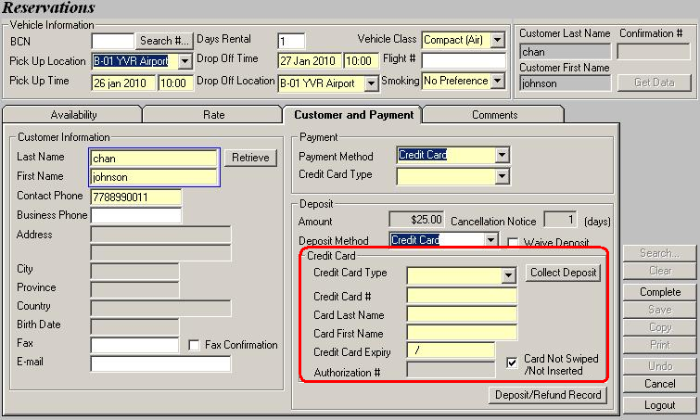
By default, the credit card fields are mandatory and ready for manual input.
Figure 16: If the customer makes a reservation over the phone, manually enter his/her credit card information.
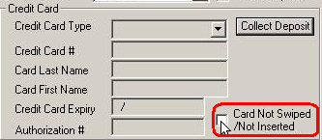

If the customer is present at the location when the reservation is made, you should deselect the Card Not Swiped/Not Inserted box. The Credit Card fields will then be grayed out as shown in Figure 17. Click on the Collect Deposit button, and the PINpad will prompt you to swipe/ insert a credit card.
Deselect the Card Not Swiped/Not Inserted box to process credit card on PINpad.
Figure 17: Deselect the option when customer is present with credit card.

You can also refund a deposit made with a credit card if the customer wishes to cancel his/her reservation. To do that, retrieve the reservation’s Confirmation # on the Reservation screen and open the Deposit/Refund Record screen. Select ‘Refund’ in the +/- column and fill in the credit card fields. The credit card you refund to must be the same credit card you used to collect deposit. Copy the Transaction ID/Receipt # and the Amount of the deposit transaction into your refund transaction. Now click Issue Refund and the transaction should go through.
GIS now allows you to collect a reservation deposit on the customer’s debit card through the same PINpad you use to process credit cards.

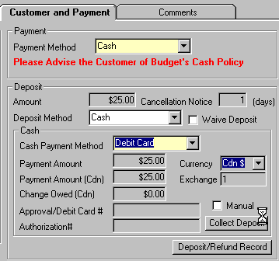
In the Customer and Payment tab, select ‘Cash’ as the Payment Method and select ‘Debit Card’ as the Cash Payment Method. Click the Collect Deposit button (See Figure 18), swipe the debit card on the PINpad and hand the PINpad to the customer for account selection and PIN identification.
Select Debit Card as the Cash Payment Method and click Collect Deposit.

Once the transaction is approved, the authorization # and customer’s debit card # are populated in GIS. Note that the debit card number is not masked because it cannot be processed on without entering the customer’s PIN.

Figure 18: Click Collect Deposit to swipe debit card on PINpad.

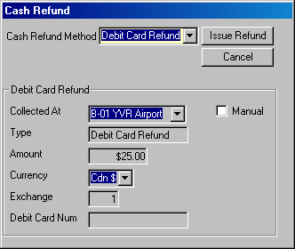
To refund a deposit made with a debit card, retrieve the reservation’s Confirmation # on the Reservation screen and click Cancel. After the Cash Refund pop up window appears, choose ‘Debit Card Refund’ as the Cash Refund Method and the pop up window will be expanded, as shown in Figure 19.

Notice that you can only refund the exact amount you collected on the debit card. Click Issue Refund, swipe the debit card on the PINpad and hand the PINpad to the customer for account selection and PIN identification.

The Reservation screen clears itself automatically after the refund is made.
Figure 19: Click Issue Refund to process refund through a
PINpad.

You can also refund a deposit made with a credit card if the customer wishes to cancel his/her reservation. To do that, retrieve the reservation’s Confirmation # on the Reservation screen and open the Deposit/Refund Record screen. Select ‘Refund’ in the +/- column and fill in the credit card fields. The credit card you refund to must be the same credit card you used to collect deposit. Copy the Transaction ID/Receipt # and the Amount of the deposit transaction into your refund transaction. Now click Issue Refund and the transaction should go through.

